CHAPTER 7
POTENTIAL ENERGY AND ENERGY CONSERVATION
Discussion Questions
Q7.1 The air resistance force is directed opposite to the motion and hence does negative work 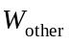, both for the upward and downward displacements of the baseball. The ball returns to the same height, so 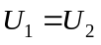. 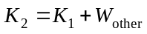; 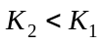 since 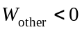.

Q7.2 At the maximum height 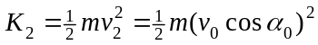, where 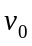 is the launch speed and 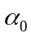 is the launch angle, since at the maximum height 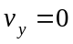 and 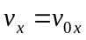. The smallest gives the largest 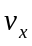 and 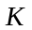 at the maximum height. 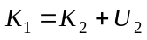 so when 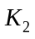 is larger, 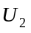 and hence 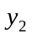 at the maximum height are smaller. That is, for smaller launch angle, the kinetic energy at the maximum height is larger, so by energy conservation the gravitational potential energy must be less. Fig.7.8 shows that smaller corresponds to smaller maximum height.

Q7.3 No Friction: The kinetic energy at the bottom equals the gravitational potential energy at the top, if the potential energy is taken to be zero at the bottom. The change in gravitational potential energy depends only on the change in height and is independent of the path, so the speed at the bottom does not depend on the shape of the ramp.
Friction: 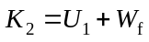. The speed at the bottom depends on the amount of mechanical energy lost due to the negative work done by friction. The work done by friction depends on the path, so the speed at the bottom depends on the shape of the ramp.

Q7.4 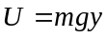. The two students assign different values to the initial and final values of the gravitational potential energy but the same value to the change in gravitational potential energy. If the height of the building is , the student on the roof says 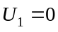, 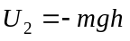 and 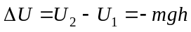. The student on the ground says 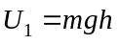, 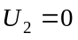 and . Conservation of energy, with 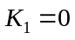 and 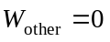, says 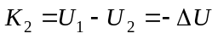, so the students assign the same value to the kinetic energy of the egg just before it strikes the ground.

Q7.5 In the absence of air resistance and any nonconservative work, 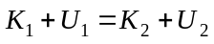. When the ball returns to its starting point, so 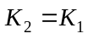. If the ball leaves his nose with some initial kinetic energy, it has the same amount of kinetic energy when it returns to his nose and it crashes into his face.

Q7.6 To increase the mechanical energy, the total work done by friction would have to be positive. Whether or not this can happen depends on the system. If you set a box on a moving conveyor belt, the friction force on the box does positive work and gives the box kinetic energy. But the friction exerted on the belt by the box does negative work on the belt. By Newton’s 3rd law the friction force exerted by the belt on the box equals the magnitude of the friction force exerted by the box on the belt. If the box doesn’t slip the magnitudes of the displacement of each object are the same and the total work done by friction is zero. If the box slips before reaching the same speed as the belt, the belt travels farther than the box and the total work done is negative. If the box is the system, friction has increased the mechanical energy. If the box and belt are the system, either the mechanical energy of the system has decreased or it has stayed the same. For an isolated system, friction never increases the mechanical energy, it is always a dissipative force.

Q7.7 She does work on the trampoline by pushing against it with her legs. This adds mechanical energy to the system.

Q7.8 A kilowatt is a unit of power. A kilowatt-hour is a unit of energy and electrical energy is what customers are paying for.

Q7.9 (a) The gravity force is downward and the displacement is upward so the gravity force does negative work. 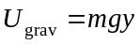, with 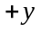upward, so the gravitational potential energy of the book increases. When a force does negative work the potential energy associated with that force increases. (b) The gravity force is downward and the displacement is downward so the gravity force does positive work. The gravitational potential energy of the can decreases. When a force does positive work the potential energy associated with that force decreases.

Q7.10 (a) The spring force on the block is directed opposite to the displacement so it does negative work. The potential energy stored in the spring increases. When a force does negative work the potential energy associated with the force increases. (b) The spring force is upward and the block moves upward so the spring force does positive work. The amount the spring is compressed decreases so the potential energy stored in the spring decreases. When a force does positive work the potential energy associated with that force decreases.

Q7.11 (a) so the 10.0-kg stone has more gravitational potential energy than the 1.0-kg stone. (b) As they free-fall, the net force on each stone is the stone’s weight 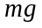. Newton’s second law says 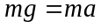 and 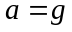, the same for each stone. The gravity force on the 10.0-kg stone is larger but more force is required to give it acceleration. (c) Conservation of energy says 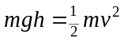, where is the final height above the ground and is the speed of the stone just before it strikes the ground. The mass divides out and 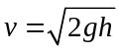, the same for both stones. They have the same acceleration and they each fall the same distance, so they have the same speed when they reach the ground. (d) The final kinetic energy of the stone equals its gravitational potential energy. The initial gravitational energy is larger for the 10.0 kg stone so the final kinetic energy is larger for this stone. Or, kinetic energy equals 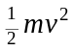. They have equal final speeds so the 10.0 kg stone has larger final kinetic energy.

Q7.12 (a) This is incorrect. (b) This is correct. The object with a smaller mass reaches a greater height. The potential energy stored in the spring does not depend on the mass of the object and is the same for both objects. Conservation of energy says that the final gravitational potential energy equals the initial potential energy stored in the spring so it is the same for both objects. For equal gravitational potential energy 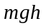 the object with the smaller mass must have a greater final height. Conservation of energy says 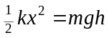 and 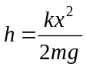.

Q7.13 The friction force that one hand exerts on the other does work and produces thermal energy.

Q7.14 Gravity is a conservative force. The work done by gravity depends only on the initial and final heights of the object. It is independent of the path and can be expressed in terms of the change in a potential energy function. Friction is a nonconservative force. The work done by friction depends on the path taken between the initial and final positions. The work done by friction therefore cannot be expressed in terms of a change in a potential energy function.

Q7.15 Work done by friction produces thermal energy that is dissipated. Heat engines (Chapter 20) can recover only a portion of the thermal energy for conversion back to mechanical energy.
Q7.16 This is incorrect. It incorrectly gives 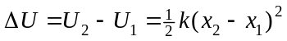 rather than the correct 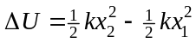. The correct form for 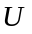 is 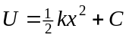, where 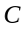 is a constant. The student’s incorrect choice gives 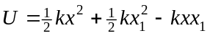. It incorrectly has a linear term in . The student’s incorrect choice gives 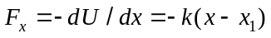, which doesn’t give 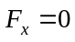 when 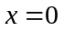. If we want 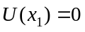, then take 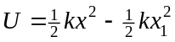. This 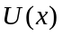 gives the correct 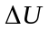 and the correct 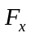.

Q7.17 If the direction of is reversed then the sign of the work is reversed and 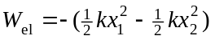. 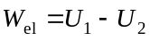 so 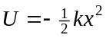. The graph of this is given in Fig. DQ7.17. is a point of unstable equilibrium. Any small displacement away from produces a force that moves the end of the spring farther from equilibrium.

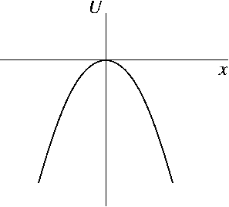

Figure DQ 7.17

Q7.18 The force is always in the 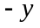-direction, which is towards the surface of the earth. The force acts to push the system toward lower potential energy and the potential energy is lowered when the object moves toward the earth.

Q7.19 If the particles repel, the force each exerts on the other does negative work when they move closer together and the potential energy increases. If the particles attract, the force each exerts on the other does positive work when they move closer together and the potential energy decreases.

Q7.20 At 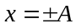, 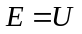 and 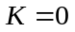. The slope of is positive at 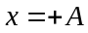, so at this point 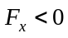 and 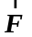 is directed opposite to the displacement. At the object stops traveling in the -direction and starts to travel in the -direction. At 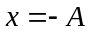, the slope of is negative so 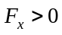 and is directed opposite to the displacement. At the object stops traveling in the -direction and starts to travel in the -direction. At the object “turns around” and starts to head in the opposite direction.

Q7.21 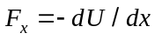, so must be constant around a point of neutral equilibrium. The graph of 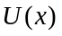versus x for a region of neutral equilibrium is given in Fig. DQ7.21. An example is a particle sitting on a horizontal, frictionless surface.

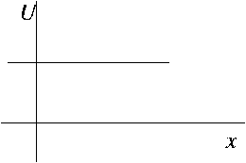

Figure DQ7.21

Q7.22 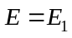: The object moves back and forth between 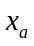 and 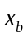. Its speed is greatest at 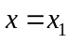. The graph of 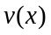 is sketched qualitatively in Fig. DQ7.22a. 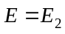: The object moves back and forth between 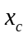 and 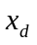. It’s speed is greatest at 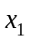. The speed has a local minimum at 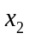 and a local maximum at 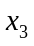. It’s speed at is slightly less than its speed at . The graph of is sketched qualitatively in Fig. DQ7.22b.

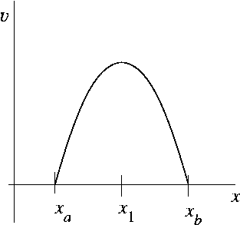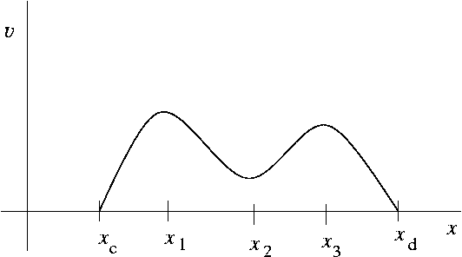

Figure DQ7.22a Figure DQ7.22b

Q7.23 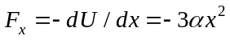. For any , , so 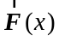 is in the 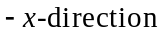, for both positive and negative x.

